LAB REPORT

for
Lab Assignment #0:
Switches & Seven-Segment Display

Document description:
This document gives a detailed lab report for the Lab Assignment #0.

Table of contents:

1. Introduction 1
2. Design Context 1
3. Design of Controller Components 1
4. In Lab Test 1
5. Conclusion 1

Introduction

This document describes a trivial lab assignment (a simple design tutorial) to be
conducted the first week of classes, before we have even had time to teach about logic
gates, except for the NOT gate, which was briefly introduced in the first lecture.
However, it engages students in working with the real board hardware and seeing real
outputs right away. At a circuit level, it is very simple, and this may help students to
more easily understand what they are doing when they are just starting to learn Quartus.
It does not include a pre-lab report requirement, because students in the Monday lab
section will not have had a chance to prepare a pre-lab report between the first lecture and
lab. However, it does include a simple design component and a lab report requirement.
-- quoted from Lab Assignment #0 document.

2. Design Context

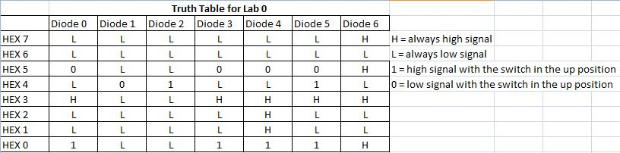

This truth table (above) describes the logic behind the 7 segment display on the birthdates of the two team members. Not only should the 8 digit dates be taken into account, but the 7 segments of each digit should as well. Luckily, not too many signals had to be switched due to the birthdates being so similar; however the logic is as illustrated by the table above.

System-level functional requirement. If the switch is up, the seven segment display shows team member 1’s birth date. If the switch is down, the seven segment display shows team member 2’s birth date.

Table 1. This table lists the two possible situations that may exist and the required behavior of the system in each one.

Situations |  | Behaviors
Sit.  # | Switch is up | Show person 1 birth date | Show person 2 birth date
1 | no | yes | no
2 | yes | no | yes

5. Design of Controller Components

Show below is the schematic created in Quartus for the seven segment display.

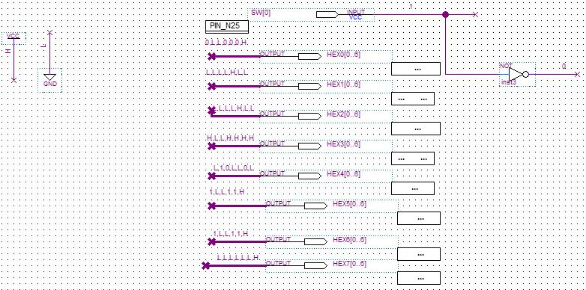

Note that the above design has the properties as illustrated in the truth table on page 1.

6. In Lab Test

At first, the given circuit board was having some malfunctions and problems, so that board was switched out. Next the program was compiled and sent to the board; however the dates were not printed correctly. In fact, the 7 segments were printed inversely. This problem was then easily fixed by switching the H’s to L’s and vice versa.

7. Conclusion

As this was the first lab assignment, many new concepts and lessons were learned. We familiarized ourselves with DE2 boards, Quartus 2 software, LED controls, 7segment display controls, and lab notebook/report convention. With the completion of this lab, I know better understand how to go through a complete simple design cycle. The eight digit dates were logically represented on the seven segment LED numeric display as directed.

